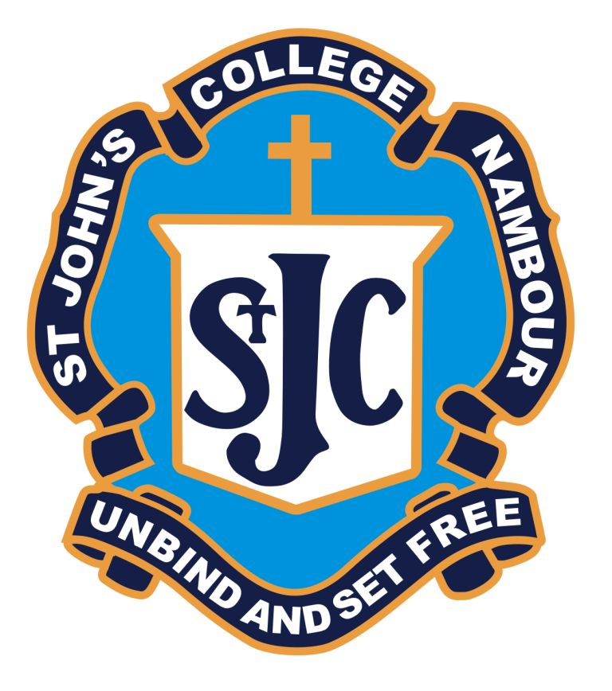
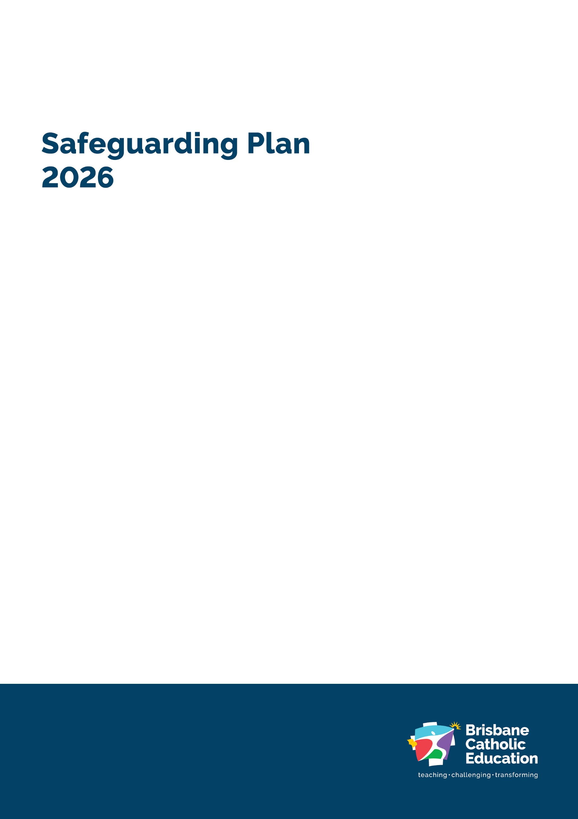
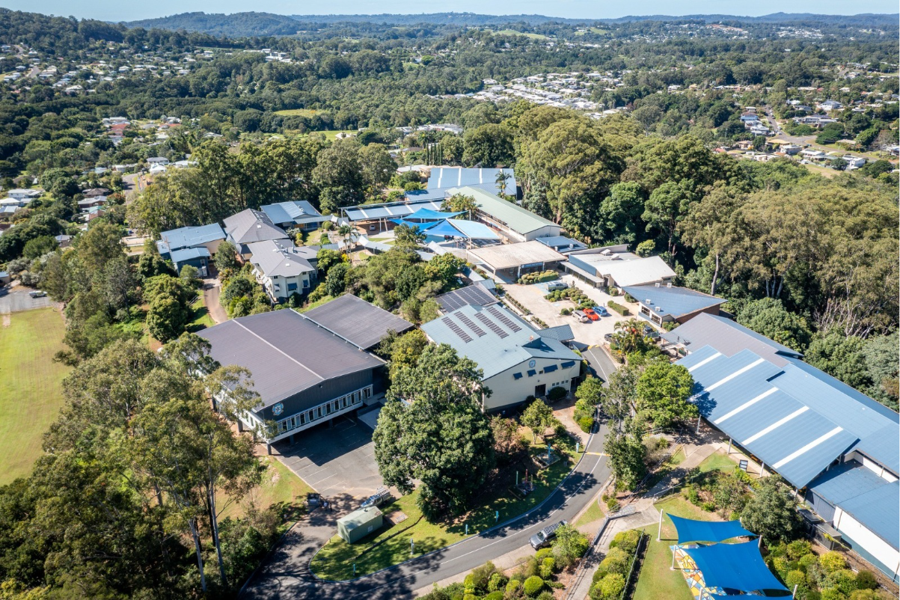
St John’s College


Our Safeguarding Commitment
As an agency of the Archdiocese of Brisbane, we have a zero tolerance for all forms of abuse and are committed to safeguarding everyone involved in its activities, ministries, and services. The safety and wellbeing of children and adults-at-risk is paramount.

Accessibility

Brisbane Catholic Education is committed to providing accessible
services to people from all culturally and linguistically diverse backgrounds. If you have difficulty understanding this document, you can contact Translating and Interpreting Service National on 13 14 50 to arrange for an interpreter to translate it for you.

Contact for enquiries

St John’s College, Nambour
Perwillowen Road, Nambour
Kabi Kabi Country,
07 5441 5666
http://www.stjohns.qld.edu.au

Attributions
Artwork: Ngulli Gumera artwork by Waylene Currie of WRLC Arts, 2025.
Cover: School Drone Photo
Page 4: School Logo
© The State of Queensland (Queensland Family and Child Commission) Guidelines for implementing the Universal Principle and Child Safe Standards in Queensland. These Guidelines and the related symbols contained in this work are adapted from material licensed under the Creative Commons Attribution (CC BY) 4.0 International licence.


Acknowledgement of Country
Songlines and legends were carved over this Land for thousands of years. From Coes Creek meandering through the area, to the top of the hill where we are now. This Land remembers the stories and footsteps of First Nations Peoples protecting the wildlife, and the Land.
We acknowledge the ongoing connection to Country of the Traditional Custodians of this college site, the Kabi Kabi peoples. We pay respect to Elders, and we thank them for nurturing their Cultures, Spiritualities and ways of living. May we continue to walk gently and respectfully together.
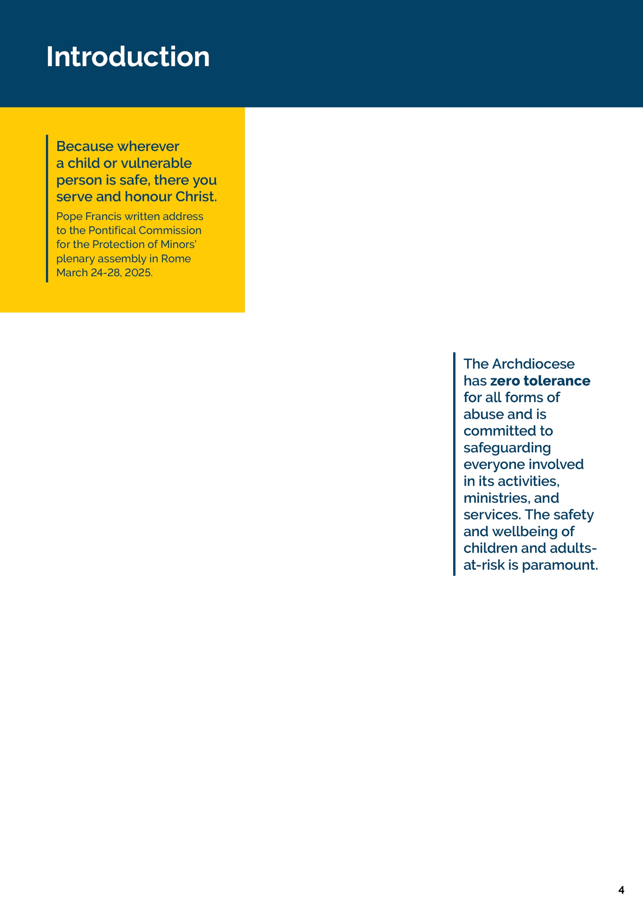
St John’s College, Nambour, is committed to creating environments where children and young people feel protected, valued, and heard. Safeguarding is a shared responsibility, and every child has the right to grow and thrive free from harm.
We are guided by our Christian Catholic Tradition and the teachings of Jesus Christ who advocated for the protection of children and the marginalised. Our mission to teach, challenge and transform through our educational endeavours is actioned by Catholic Social Teaching, as part of the Archdiocese of Brisbane.
The Queensland Government recently introduced new Child Safe Standards. These Standards clearly outline what child safe organisations must do to create environments where children are protected, respected and able to speak up. They focus on building safe, welcoming cultures, hearing and valuing children’s voices, working closely with families, celebrating diversity, making sure the right people work with children, responding quickly to concerns, and always looking for ways to improve safety.
Throughout 2026, our school will review its compliance against the new Child Safe Standards using a phased approach in line with Queensland Family and Child Commission guidelines. We will review, self-assess and report against selected Standards each term, building towards full implementation and continuous improvement across all Standards by the end of the year. This staged process allows St John’s College to embed the Standards meaningfully and ensure our practices reflect the needs, voices and safety of our students.
As a Catholic school within the Archdiocese of Brisbane, we honour the Archdiocesan Safeguarding Commitment and uphold the values of Catholic education in our safeguarding practices.
This School Safeguarding Plan is developed in consultation with students, families, and employees, and is contextualised to our local school environment. It reflects our commitment to continuous improvement, cultural safety, and child-centred practice, and is supported by both Brisbane Catholic Education policies and procedures and school-specific safeguarding actions. Further Information about BCE wide practices can be accessed here.
For more information or to request accessible formats, please contact the school Principal.
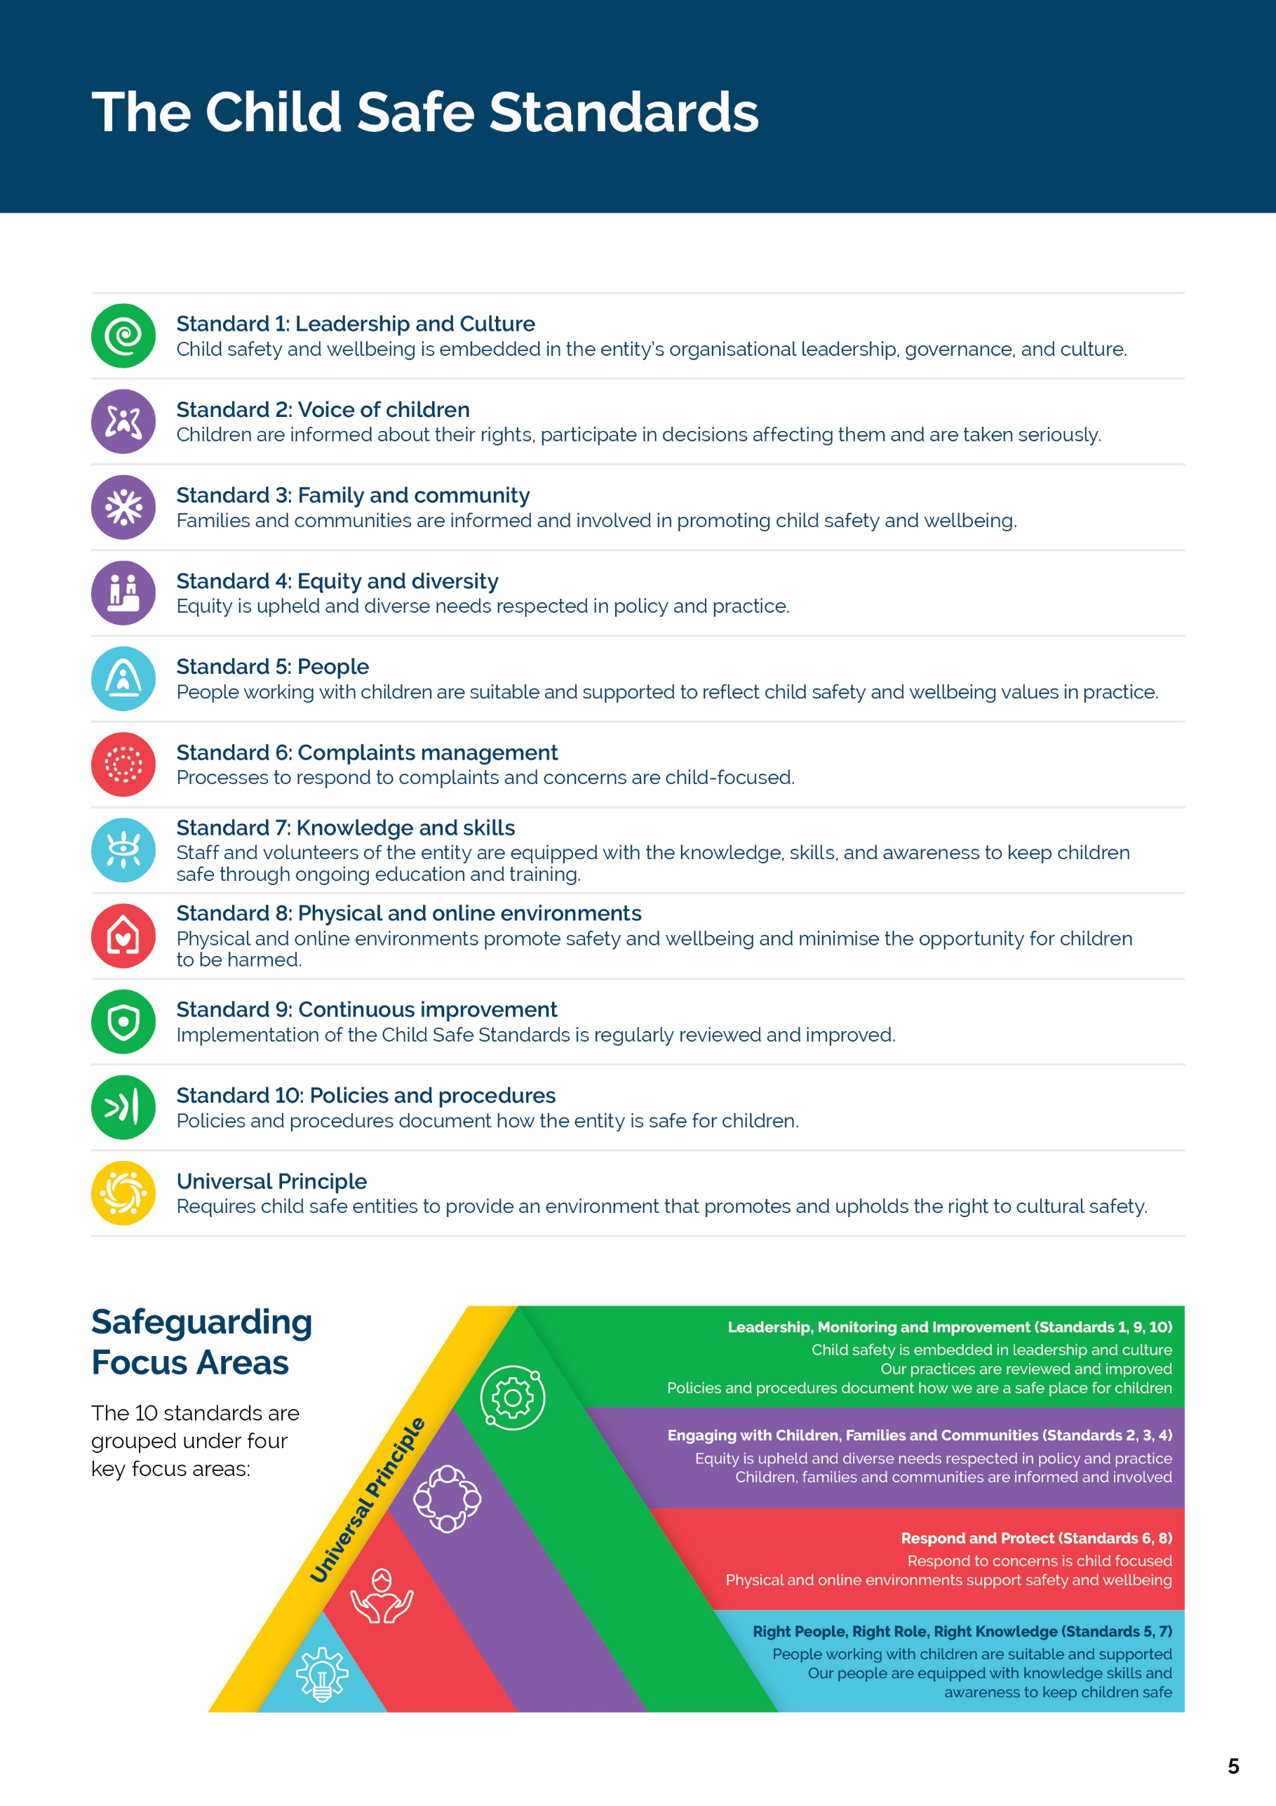

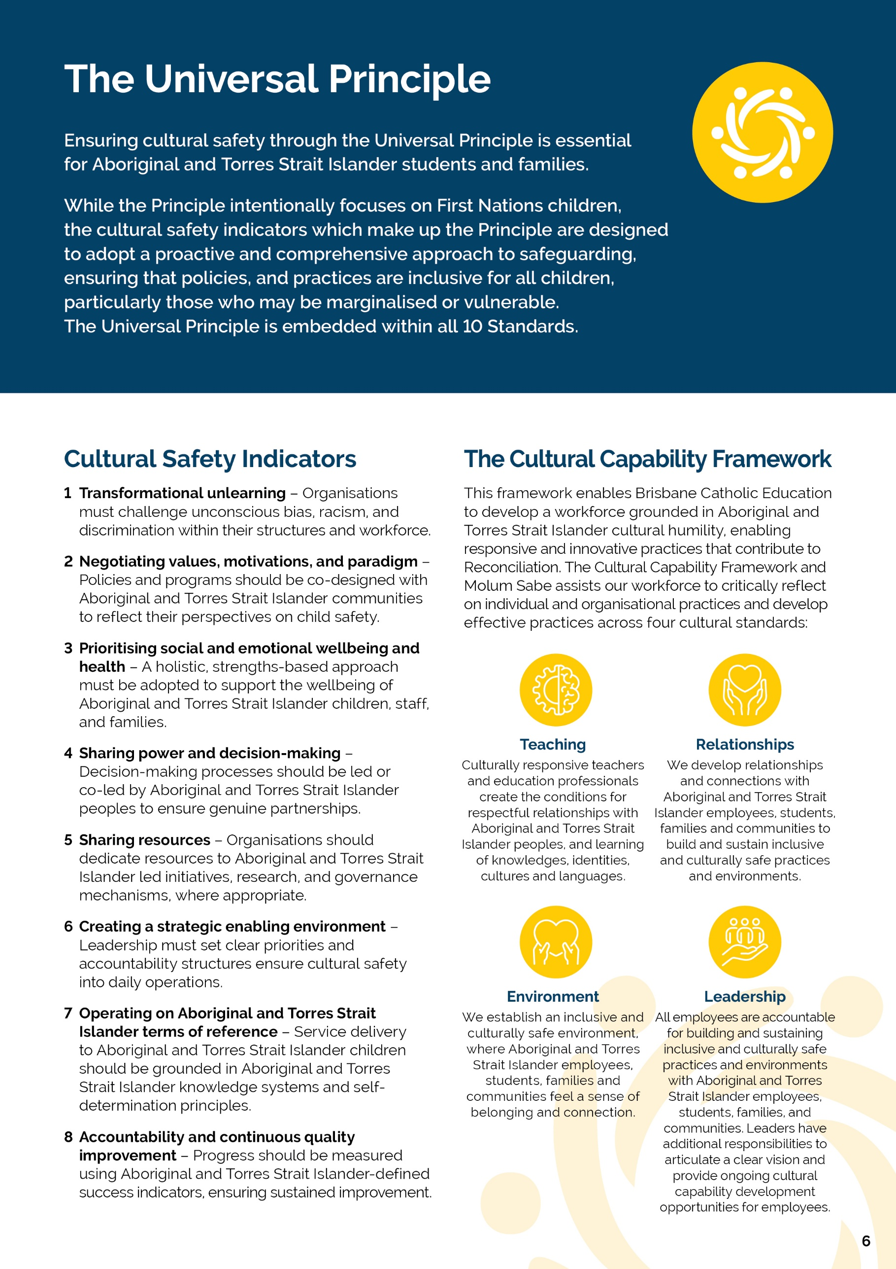
[St John’s College] | Safeguarding Plan 2026

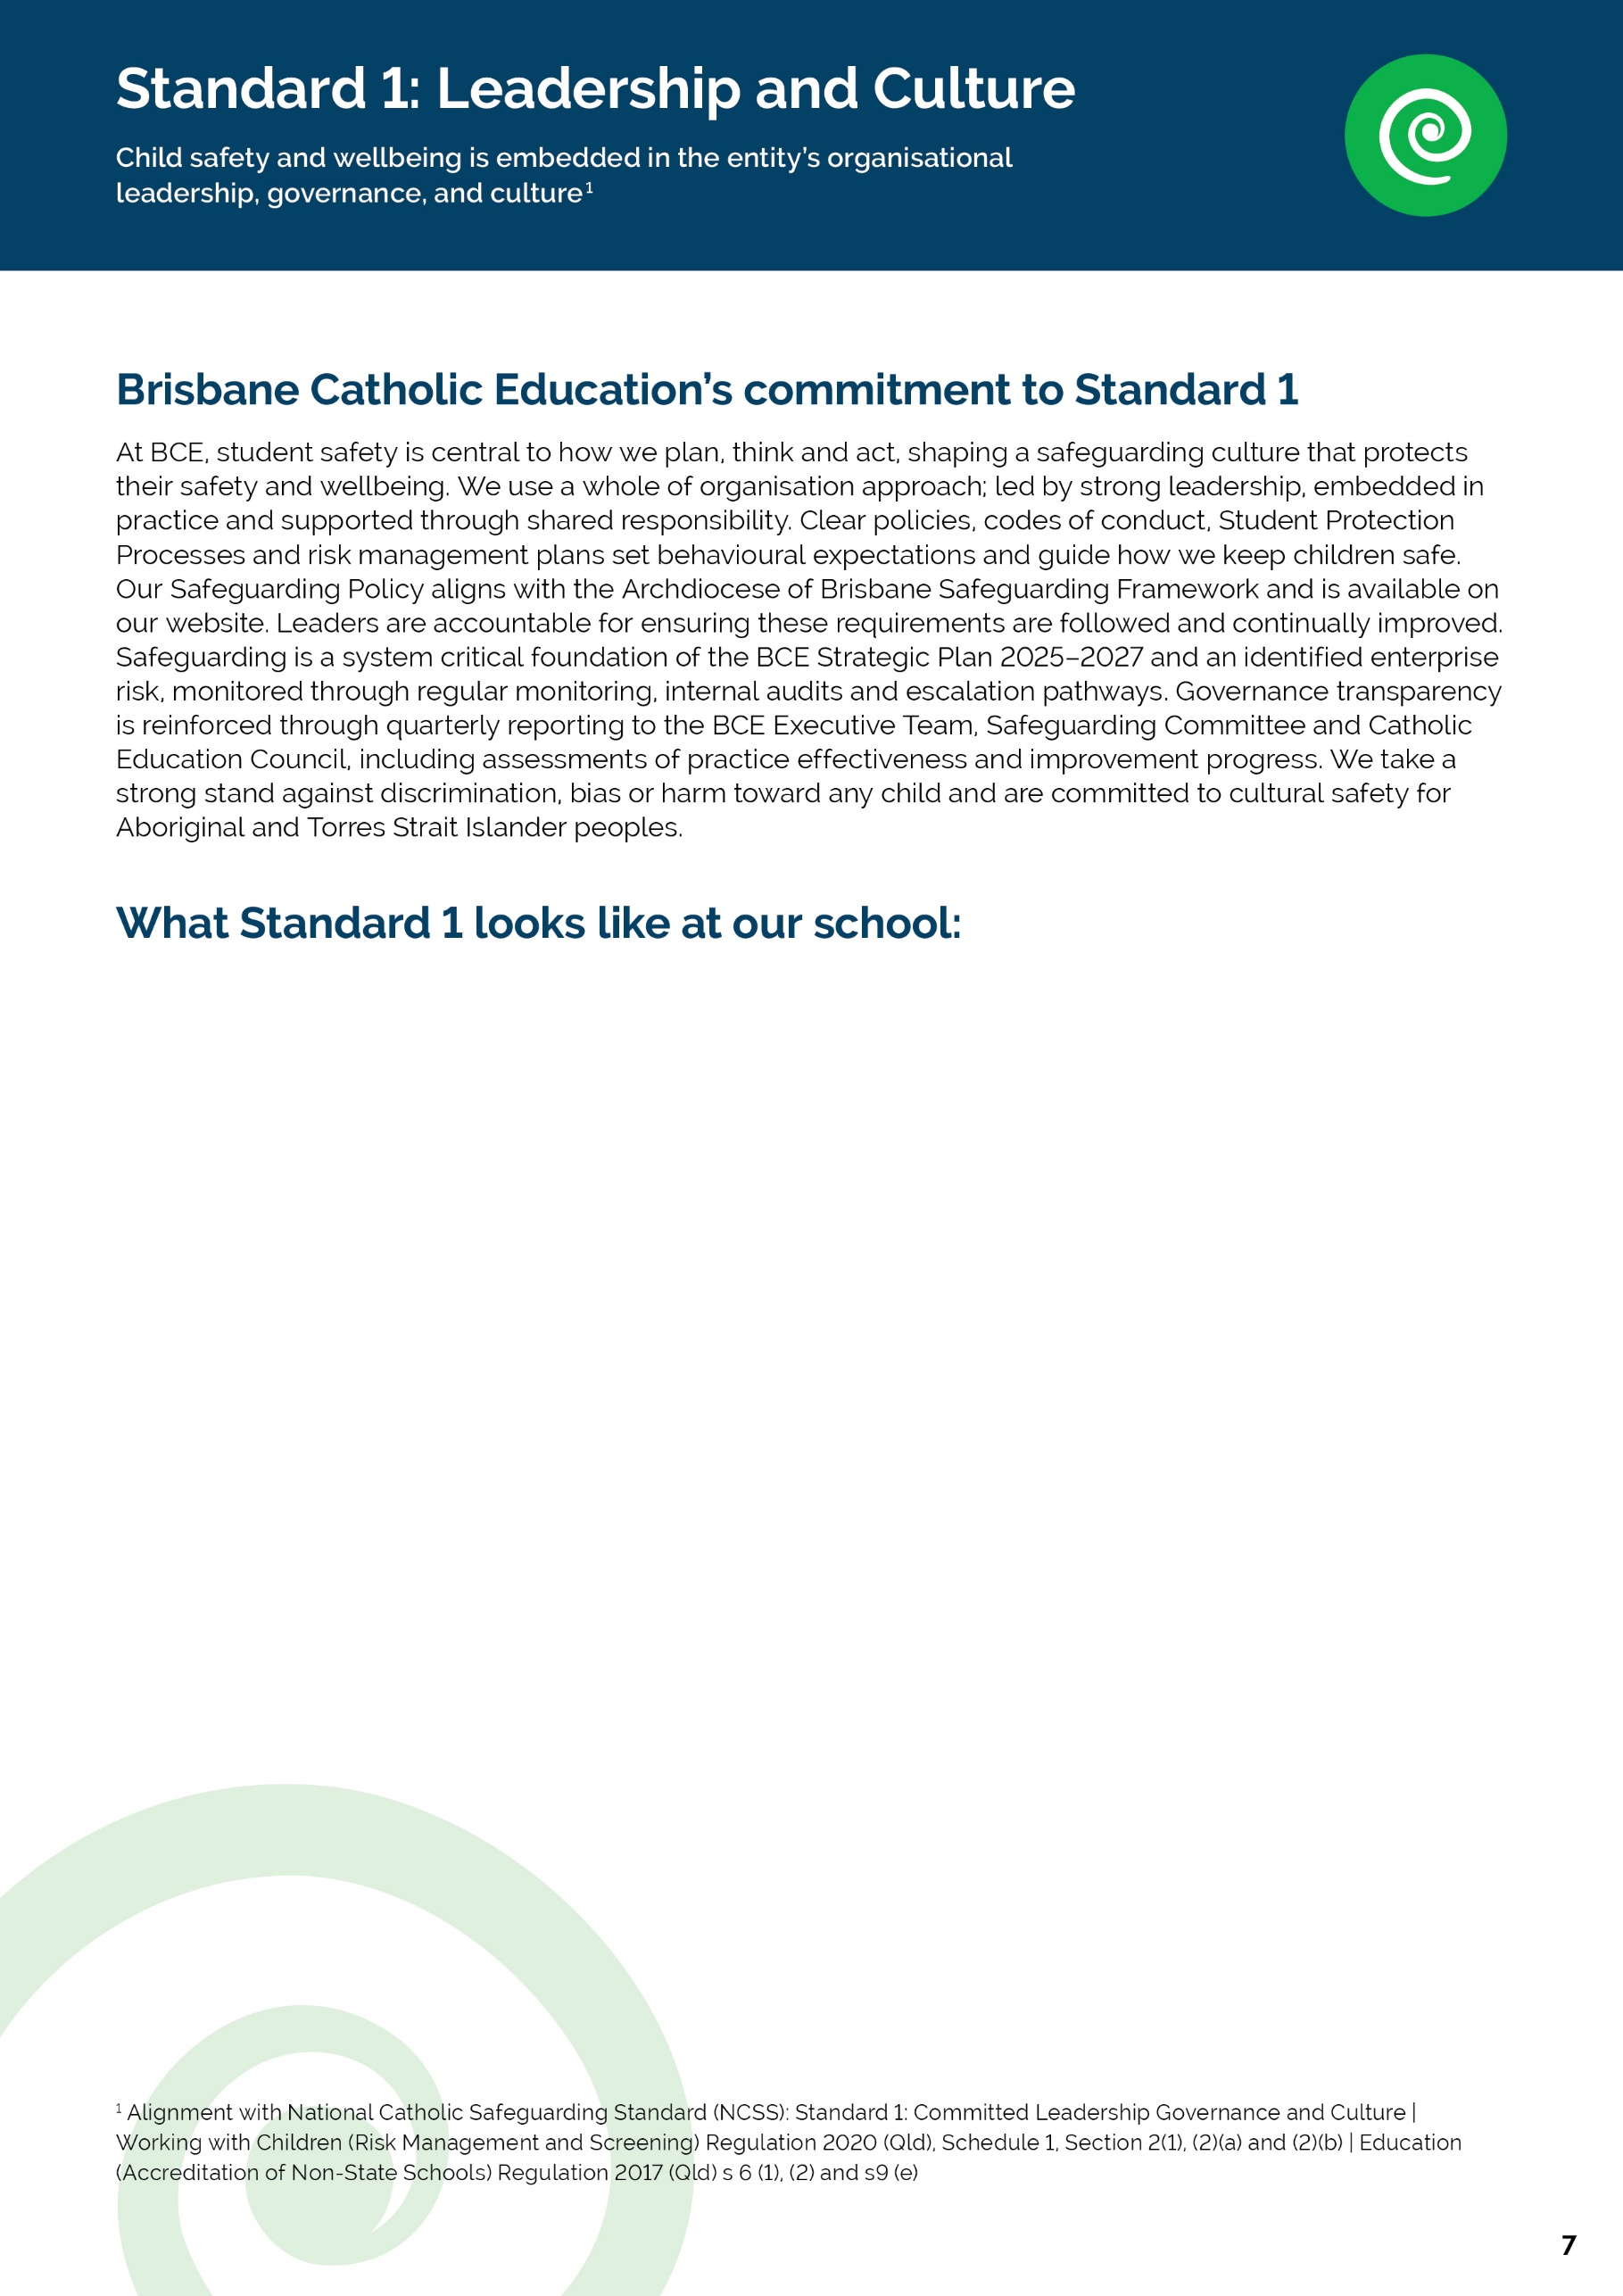

Student wellbeing is embedded in leadership and staff structures - At St John’s College, student wellbeing and safeguarding are standing agenda items. Student wellbeing is discussed at every Monday staff briefing, with leadership members identifying and addressing emerging areas of concern. In addition, weekly leadership meetings include an “Around the Grounds” focus, ensuring proactive oversight of student wellbeing and safeguarding across the College.
Safeguarding is actively supported through preventative education - In alignment with BCE’s commitment to a safeguarding culture, St John’s College prioritises preventative education. In Term 1, the College hosts an Internet Safeguarding Day for both parents and students, strengthening shared responsibility for online safety and reinforcing safe behaviours within and beyond the school environment.
Risk management processes prioritise student safety and wellbeing - Consistent with BCE’s risk management expectations, a comprehensive risk assessment is completed prior to every excursion. These assessments explicitly address student safety and wellbeing, including supervision ratios, student privacy considerations, transport arrangements, and media consent, ensuring safeguarding responsibilities are clearly identified and managed.
Inclusive leadership structures support diverse student needs -As part of the College’s Inclusion Policy, St John’s College has a designated Inclusion Program Leader, providing clear leadership accountability for inclusive practices. This role supports culturally safe, equitable, and responsive approaches to student wellbeing, particularly for students requiring additional learning, wellbeing, or cultural support.
Commitment to cultural safety and inclusion beyond the College community -Reflecting BCE’s commitment to cultural safety for Aboriginal and Torres Strait Islander peoples, St John’s College hosts an annual Cultural Inclusion Day for ATSI students from other BCE schools. This initiative promotes belonging, cultural identity, and wellbeing, and demonstrates the College’s active leadership in inclusion and safeguarding across the wider BCE community.
[St John’s College] | Safeguarding Plan 2026

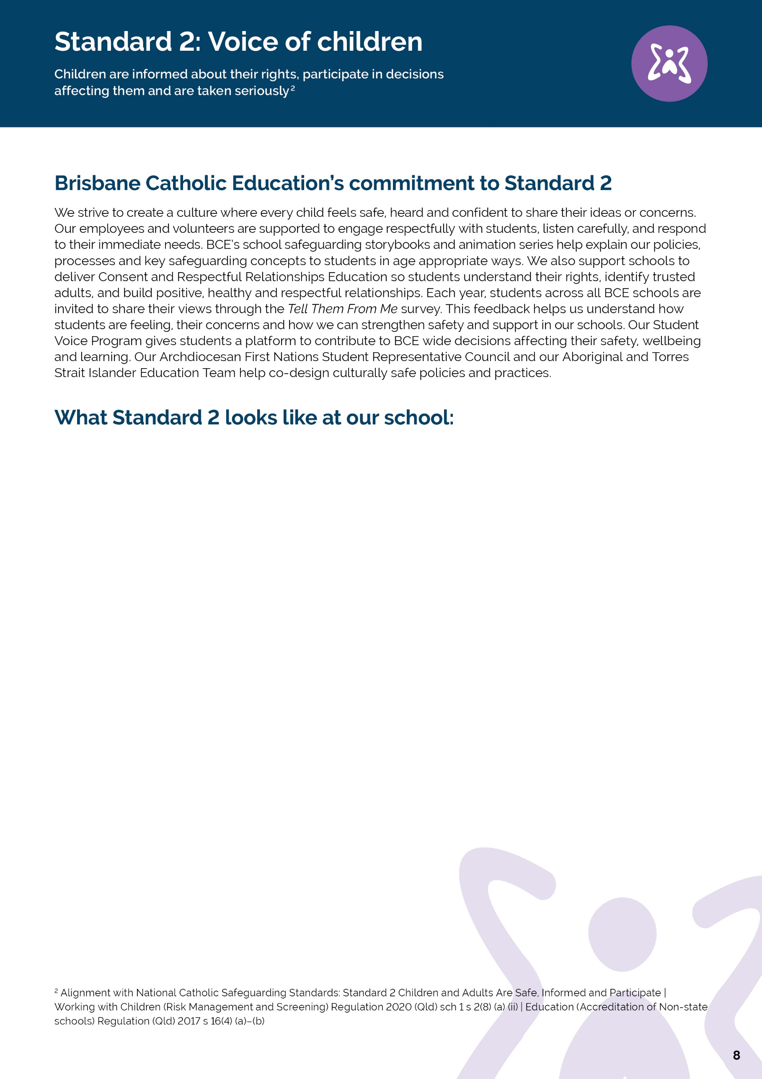

At St John’s College Nambour, we are committed to ensuring that every student understands their rights, feels safe, knows who they can trust, and has meaningful opportunities to participate in shaping their school experience. Through our curriculum, pastoral care structures and wellbeing programs, students learn about personal safety, respectful relationships, consent, protective behaviours and help-seeking strategies in age-appropriate ways. These messages are reinforced through assemblies, wellbeing check-ins, student leadership opportunities, Child Protection Week, R U OK? Day activities, visible signage, and targeted responses to emerging issues such as online safety.
Students are provided with a range of trusted avenues to seek support, including teachers, pastoral leaders, Guidance Counsellors, student leadership teams and external services such as Kids Helpline. Information about these supports is communicated through classrooms, assemblies, digital platforms and pastoral structures to ensure students know how and when to access help.

Student voice is a valued and integral part of College life. Students are encouraged to express their views, ask questions and raise concerns through classroom discussions, wellbeing check-ins, reflective activities, student leadership groups, pastoral care programs and informal conversations with staff. Multiple pathways, including one-on-one conversations and anonymous feedback opportunities, help ensure all students can participate in ways that are safe, accessible and appropriate to their individual needs.

Student participation influences decision-making across the College through consultation processes, student leadership structures, wellbeing initiatives and ongoing feedback mechanisms. Student perspectives help inform the development of programs, activities and responses to emerging wellbeing and safety issues, ensuring that decisions reflect the lived experiences and needs of our young people.

Cultural safety underpins our approach to student wellbeing and safeguarding. We are committed to creating inclusive environments where all students feel respected, valued and able to contribute. Staff actively adapt practices and communication strategies to meet the diverse cultural, developmental and learning needs of students, while pastoral programs, peer mentoring, buddy systems and inclusive activities foster belonging, connection and positive relationships. Restorative practices further support students to develop respectful and healthy relationships with others.
Evidence of practice includes the delivery of consent and respectful relationships education, regular wellbeing check-ins, student leadership and representative structures, pastoral care programs, access to counselling services, safeguarding resources, and whole-school awareness initiatives. Planned improvements include strengthening the continuity of safety and wellbeing learning across all year levels through a clearly mapped whole-school scope and sequence, increasing staff capability and confidence in delivering safeguarding education, enhancing the visibility and accessibility of support services, and reviewing resources to ensure they are culturally responsive and reflective of the diversity of the College community

[St John’s College] | Safeguarding Plan 2026
[School Name] | Safeguarding Plan 2026

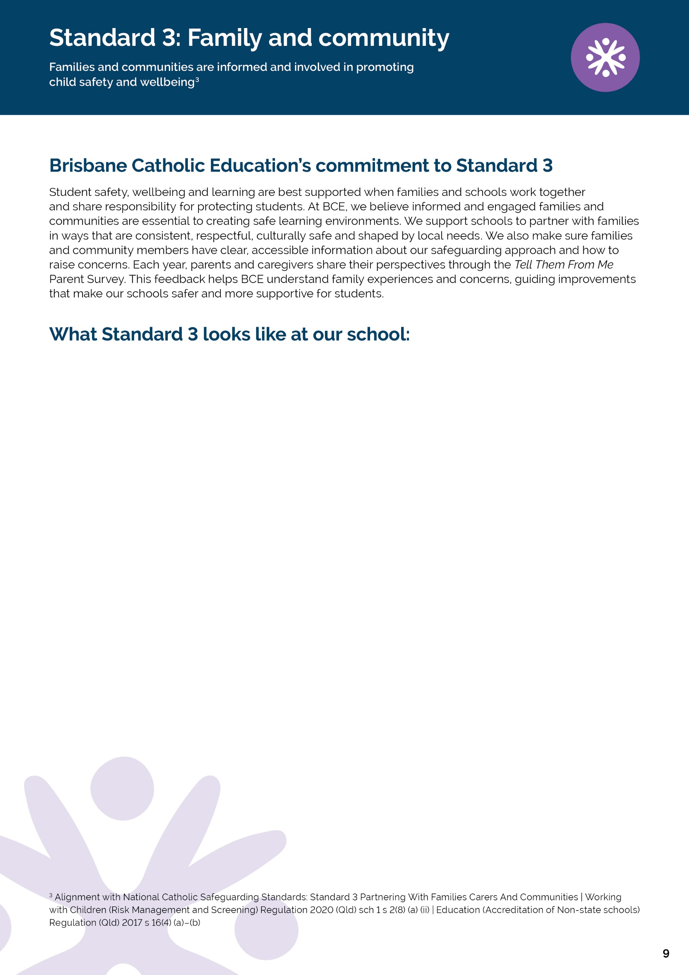

At St John’s College Nambour, safeguarding and student wellbeing are strengthened through strong partnerships between students, families, staff and the wider community. The College is widely regarded by families as supportive, approachable and committed to the safety and wellbeing of every student. Staff and school leaders demonstrate a strong and consistent commitment to safeguarding, inclusive practice and positive relationships, with student safety embedded in the daily life of the College.

The College communicates safeguarding expectations and wellbeing information through enrolment processes, parent handbooks, newsletters, the College website, information sessions and direct communication from staff and leadership. Families are regularly informed about support services, reporting pathways and wellbeing initiatives, and are provided with resources relating to topics such as online safety, mental health and respectful relationships. Where required, communication is adapted to meet the needs of families from diverse cultural and linguistic backgrounds.

Families and community members actively participate in student safety and wellbeing initiatives through parent information evenings, parent-teacher meetings, liturgies, sporting events, community celebrations and College information sessions. These opportunities support shared understanding of student wellbeing priorities and strengthen relationships between home and school.

The College engages with the Parents and Friends Association, parish and community organisations, wellbeing professionals and external support agencies to enhance student wellbeing and promote a culture of safety, inclusion and belonging. These partnerships provide valuable opportunities to strengthen support networks for students and families and ensure community perspectives contribute to College decision-making.

Feedback is gathered through parent surveys, conversations, community engagement opportunities and participation in College events. This feedback helps the College evaluate the effectiveness of communication, identify areas for improvement and respond to emerging needs. Current feedback indicates strong confidence in the College’s commitment to student wellbeing, while also highlighting opportunities to improve the visibility and understanding of safeguarding processes and cultural safety practices.

Evidence of practice includes regular communication with families, responsive support for student wellbeing concerns, strong family engagement across College events, parent education opportunities and collaboration with community partners. Planned improvements include making safeguarding and cultural safety practices more visible and accessible, using clearer and more consistent communication, increasing opportunities for family voice and consultation, strengthening partnerships with diverse community groups, and embedding key wellbeing and safeguarding messages more intentionally across community events and communications.

Through these actions, St John’s College Nambour will continue to strengthen shared responsibility for student safety and wellbeing and build a deeper understanding of safeguarding across the entire College community.

[St John’s College] | Safeguarding Plan 2026
[School Name] | Safeguarding Plan 2026

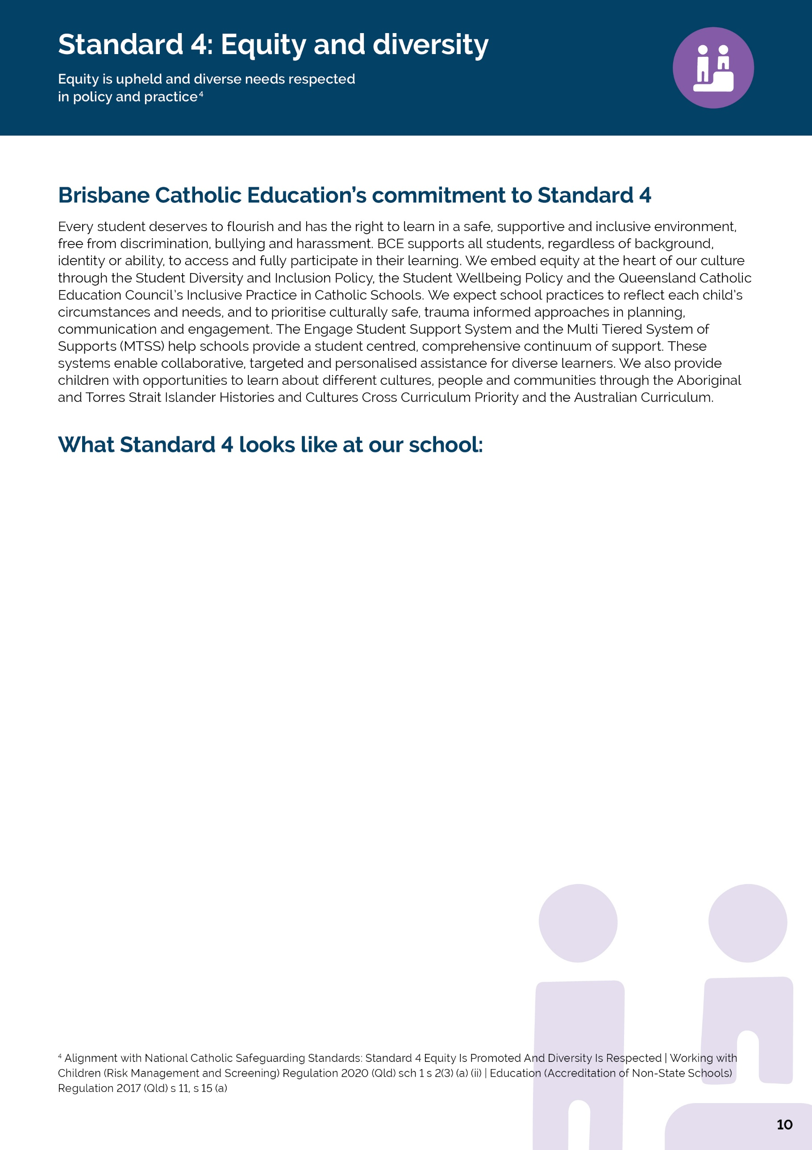
[St John’s College] | Safeguarding Plan 2026

At St John’s College Nambour, we are committed to fostering a safe, inclusive and respectful learning environment where every student is valued, supported and able to participate fully in school life. Our approach is grounded in equity, recognising that students have diverse backgrounds, experiences and needs, and that some students may require additional support or adjustments to access learning, wellbeing and safety on an equitable basis.

The College provides a range of supports for diverse learners through differentiated teaching practices, wellbeing planning, pastoral care structures, Guidance Counsellor support, Multi-Tiered Systems of Support (MTSS), and individualised adjustments developed in partnership with students, families and support teams. Staff work proactively to identify students who may be vulnerable or require additional assistance, using wellbeing and engagement data, professional judgement, family partnerships and ongoing monitoring to ensure support is responsive and timely.
Cultural safety and anti-discrimination practices are embedded through trauma-informed, relational and strengths-based approaches that respect the dignity, identity and experiences of all students. Staff engage in ongoing professional learning to strengthen culturally responsive practices and to ensure decisions are informed by empathy, inclusion and an understanding of individual circumstances. The College values diverse perspectives and recognises the importance of culture, identity and community in student wellbeing, including a commitment to respectful engagement with Aboriginal and Torres Strait Islander peoples and perspectives.

Students are supported to understand their rights, safety and available support pathways through classroom learning, pastoral programs, assemblies, wellbeing initiatives and visible safeguarding resources. Information is presented in age-appropriate and accessible ways, with communication adapted through visual supports, repetition and culturally responsive practices to meet the needs of diverse learners. Students are regularly reminded of who they can talk to and how to seek help when they have concerns about their safety or wellbeing.

Evidence of practice includes differentiated learning supports, wellbeing monitoring, student protection processes, guidance services, trauma-informed practices, culturally responsive approaches and ongoing collaboration with families and support services. Planned improvements include strengthening student voice, particularly for students with additional needs; reviewing the accessibility and cultural safety of support pathways; enhancing volunteer induction and formation in safeguarding and cultural responsiveness; deepening engagement with First Nations voices and communities; and strengthening evaluation processes to better measure the impact of supports on student wellbeing, belonging and engagement.

[School Name] | Safeguarding Plan 2026

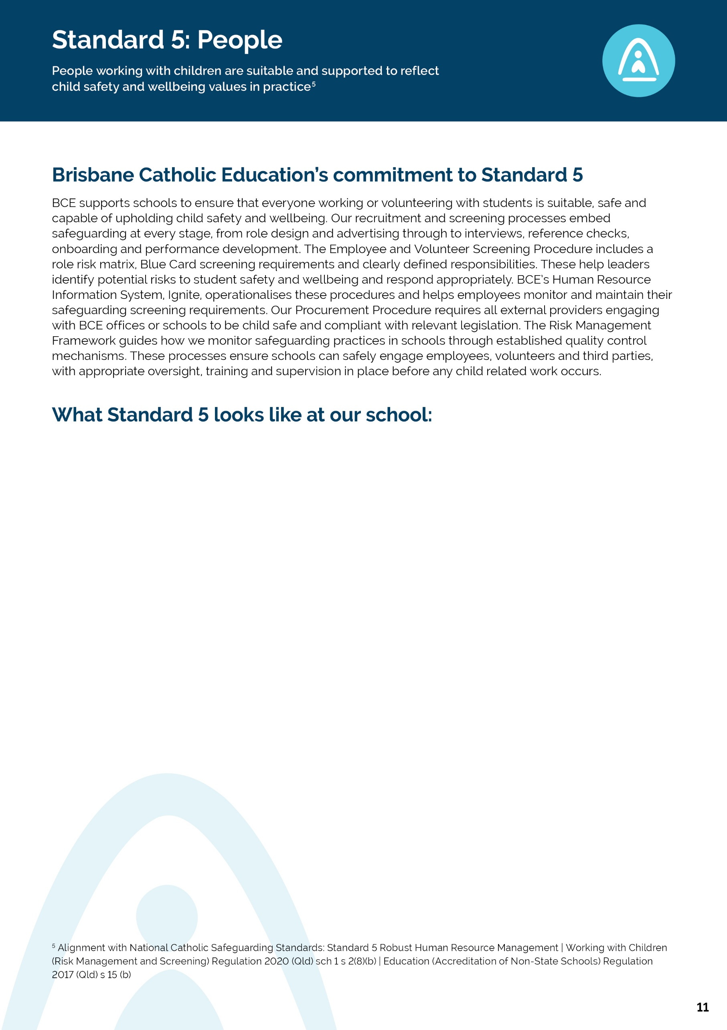
[St John’s College] | Safeguarding Plan 2026

In line with our implementation plan, at the end of Term 4 we will explain:

• How we screen and onboard employees, volunteers and third parties
• How we ensure safe supervision and conduct
• How we apply BCE recruitment and HR procedures for employees and volunteers
• How we track and keep safeguarding screening requirements current
• Evidence of practice and planned improvements
[School Name] | Safeguarding Plan 2026

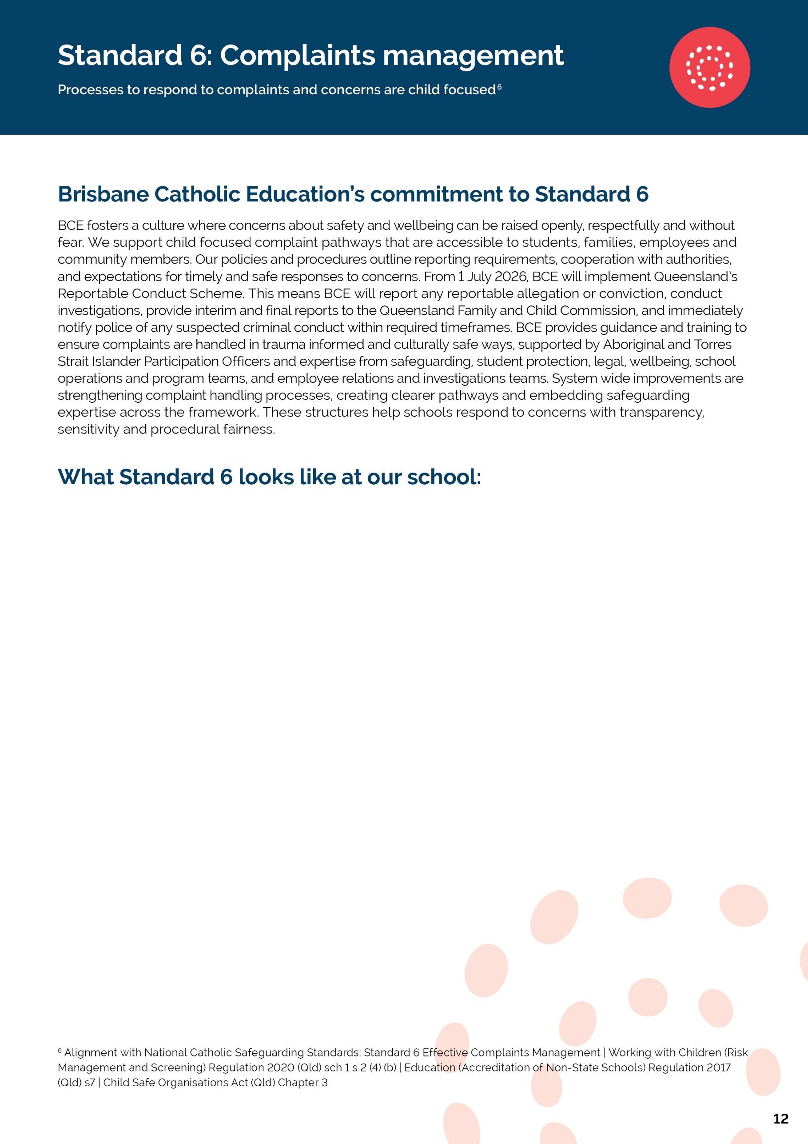
At St John's College, Nambour, we encourage students, parents and caregivers to raise worries, concerns or complaints as early as possible. We believe that speaking up is an important part of safeguarding and creating a school where every student feels safe, respected, valued and heard. Our commitment is grounded in the Brisbane Catholic Education Safeguarding Framework, which recognises that effective complaint management is child-focused, culturally safe and centred on the wellbeing of every student.

Students are regularly reminded that there are many trusted adults available to support them, including their Pastoral Middle Leader (PML), Classroom Teachers, Curriculum Middle Leaders, Assistant Principals, Guidance Counsellors, Student Protection Contacts, College Leadership Team and Principal. Information about seeking help and reporting concerns is reinforced through Pastoral Care lessons, College assemblies, Student Protection posters displayed throughout the College, the College website and everyday interactions with staff. These consistent messages help create a culture where asking for help is recognised as a normal and valued part of belonging to the St John's community.

Throughout the year, St John's intentionally promotes student voice and safeguarding awareness through Pastoral Care, Student Protection education, Consent and Respectful Relationships learning, Wellbeing programs, student leadership opportunities and participation in College and Brisbane Catholic Education student surveys, including Tell Them From Me. These opportunities allow students to share their experiences, contribute to school improvement and strengthen our safeguarding culture. Families are regularly informed about safeguarding through newsletters, parent information evenings, the College website, social media and direct communications. Staff participate in ongoing safeguarding, student protection and complaint-handling professional learning to ensure consistent practice across the College.

When a concern or complaint involves a student, our response is child-centred, trauma-informed and culturally safe. Staff seek to minimise repeated questioning, use calm and age-appropriate language, provide appropriate time and space for students to share their concerns, involve trusted adults where appropriate, and ensure students receive the support they need before, during and after the process. Our aim is that every student feels listened to, respected and supported while reducing the risk of further distress.

All concerns are managed in accordance with Brisbane Catholic Education's Student Protection Processes, Complaints Policy, Behaviour Procedures and Safeguarding Framework. The College Leadership Team and Student Protection Contacts understand when matters can be managed locally and when they must be referred to Brisbane Catholic Education, Queensland Police or other external agencies. This ensures concerns are managed through the appropriate process by the appropriate people, while maintaining procedural fairness, confidentiality and the safety and wellbeing of everyone involved.

As part of our commitment to continuous improvement, St John's College regularly reviews safeguarding practices through student, parent and staff feedback, Brisbane Catholic Education assurance processes, internal compliance reviews and reflection on complaint trends. This ongoing review strengthens our safeguarding culture and ensures our complaint processes remain accessible, transparent and responsive to the needs of our community.

[St John’s College] | Safeguarding Plan 2026
[School Name] | Safeguarding Plan 2026

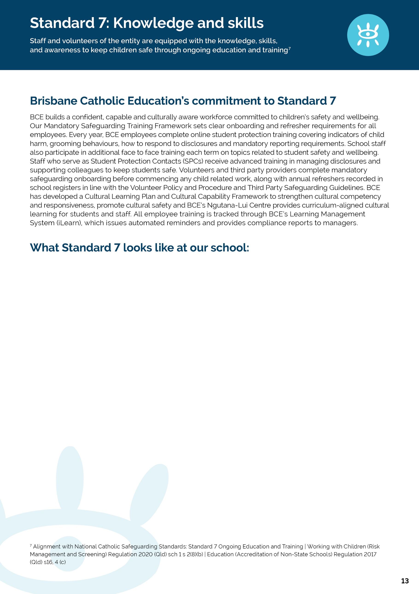
[St John’s College] | Safeguarding Plan 2026
In line with our implementation plan, at the end of Term 4 we will explain:
• How employees, volunteers and third parties complete required safeguarding training
• How the school reinforces safeguarding practice throughout the year
• How cultural capability is embedded in training
• How the school monitors and supports employees and volunteers to undertake mandatory training
• Evidence of practice and planned improvements
[School Name] | Safeguarding Plan 2026
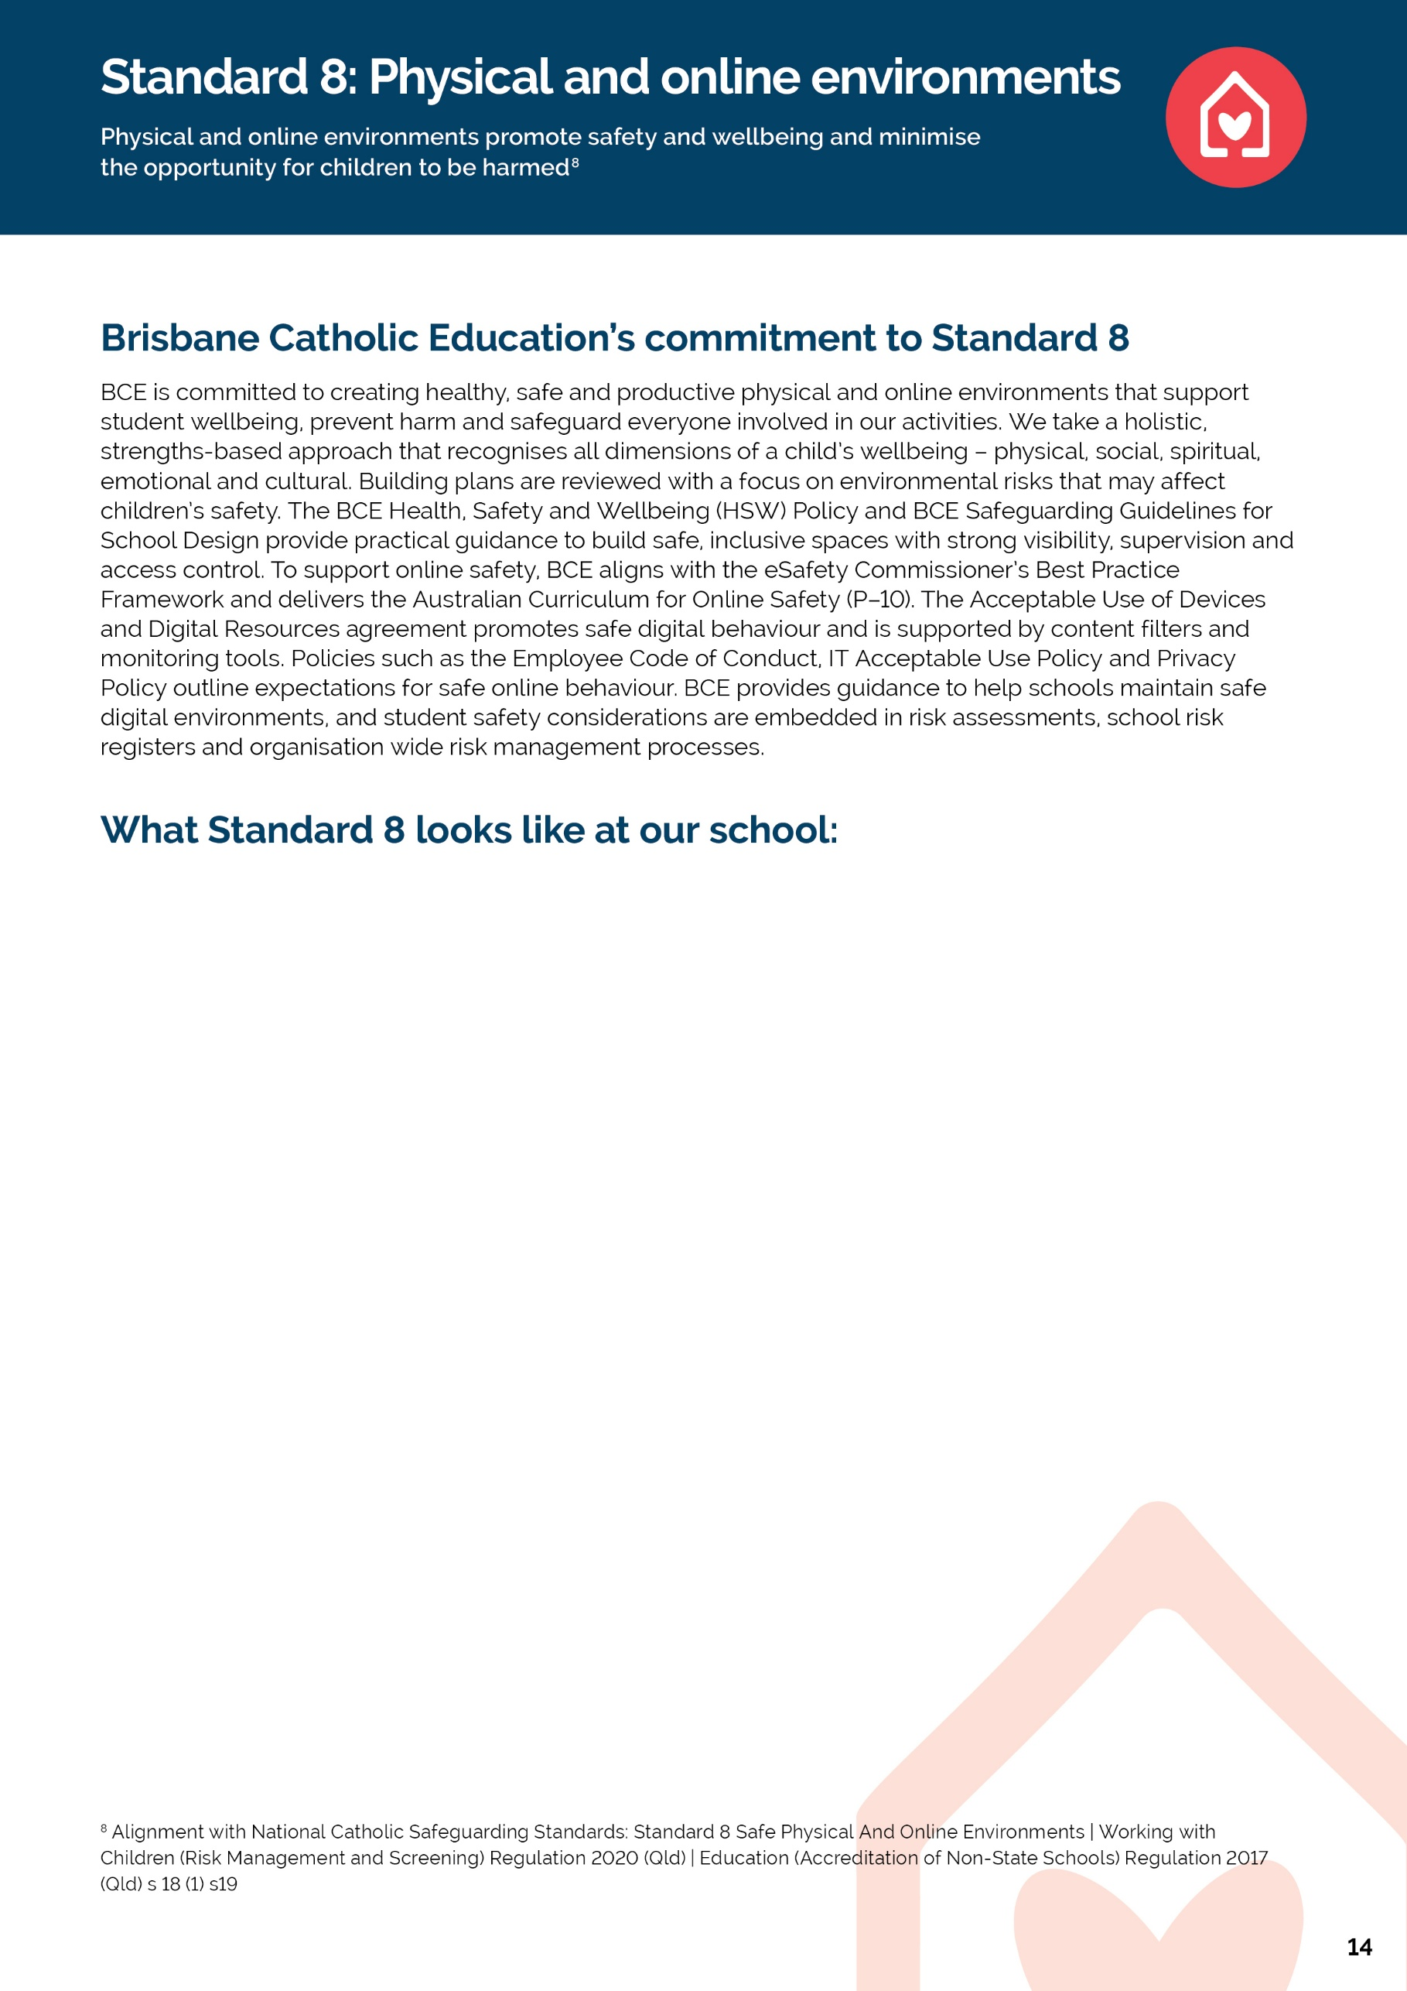

At St John's College, Nambour, the safety and wellbeing of every student underpins all aspects of College life. Safeguarding is embedded across the entire school day, including arrival and departure, learning and teaching, Pastoral Care, prayer and liturgy, break times, transitions between classes, sporting activities, camps, excursions, retreats, co-curricular programs, student support services and online learning environments. Through our Multi-Tiered System of Supports (MTSS), Positive Behaviour for Learning (PB4L) framework and pastoral structures, staff know students well and proactively respond to individual wellbeing, learning and safeguarding needs. Students are supported through predictable routines, positive relationships, restorative practices, access to trusted adults and targeted interventions where additional support is required – safeguarding is everyone’s responsibility.

Risk management is embedded within the College's planning and decision-making processes. Comprehensive risk assessments are completed for all excursions, camps, sporting events, incursions and activities involving third-party providers. These assessments consider supervision, visibility, access control, environmental hazards, cultural safety, student wellbeing, individual student needs, emergency management and legislative compliance. Risk controls are regularly reviewed through incident reports, behaviour and wellbeing data, student and staff feedback, and leadership oversight to ensure continuous improvement in safeguarding practices.

Active supervision is a core safeguarding practice at St John's College. Clearly defined duty rosters, staff briefings and established supervision expectations ensure staff remain visible, proactive and responsive during higher-risk times, including before and after school, break times, class transitions, bus duty and wet weather routines. The College continually reviews supervision arrangements to promote safe, orderly and inclusive learning environments where every student is known, supported and able to thrive.

Consistent with the Brisbane Catholic Education Cultural Capability Framework and the Universal Principle, St John's College is committed to fostering a culturally safe and inclusive environment where every student experiences a genuine sense of belonging. The College values the perspectives of Aboriginal and Torres Strait Islander students, families and community members and seeks ongoing feedback to strengthen culturally responsive practices, relationships, learning environments and decision-making. This commitment is reflected through curriculum, community partnerships, acknowledgement of Country, celebration of First Nations cultures and continual reflection on our practices.

St John's College promotes safe and responsible use of technology through Brisbane Catholic Education's approved digital platforms, network filtering, privacy protections and the Student Acceptable Use Agreement. Students are explicitly taught respectful online behaviour through Pastoral Care, Consent and Respectful Relationships Education and Digital Citizenship programs. Staff actively respond to concerns involving cyberbullying, online harassment, inappropriate communication, racism, discrimination or the unsafe sharing of digital content. Recognising that online behaviour can significantly impact student wellbeing at school, the College continues to strengthen student education, family engagement and help-seeking pathways to ensure all students feel safe, respected and supported in both physical and online environments.

[St John’s College] | Safeguarding Plan 2026
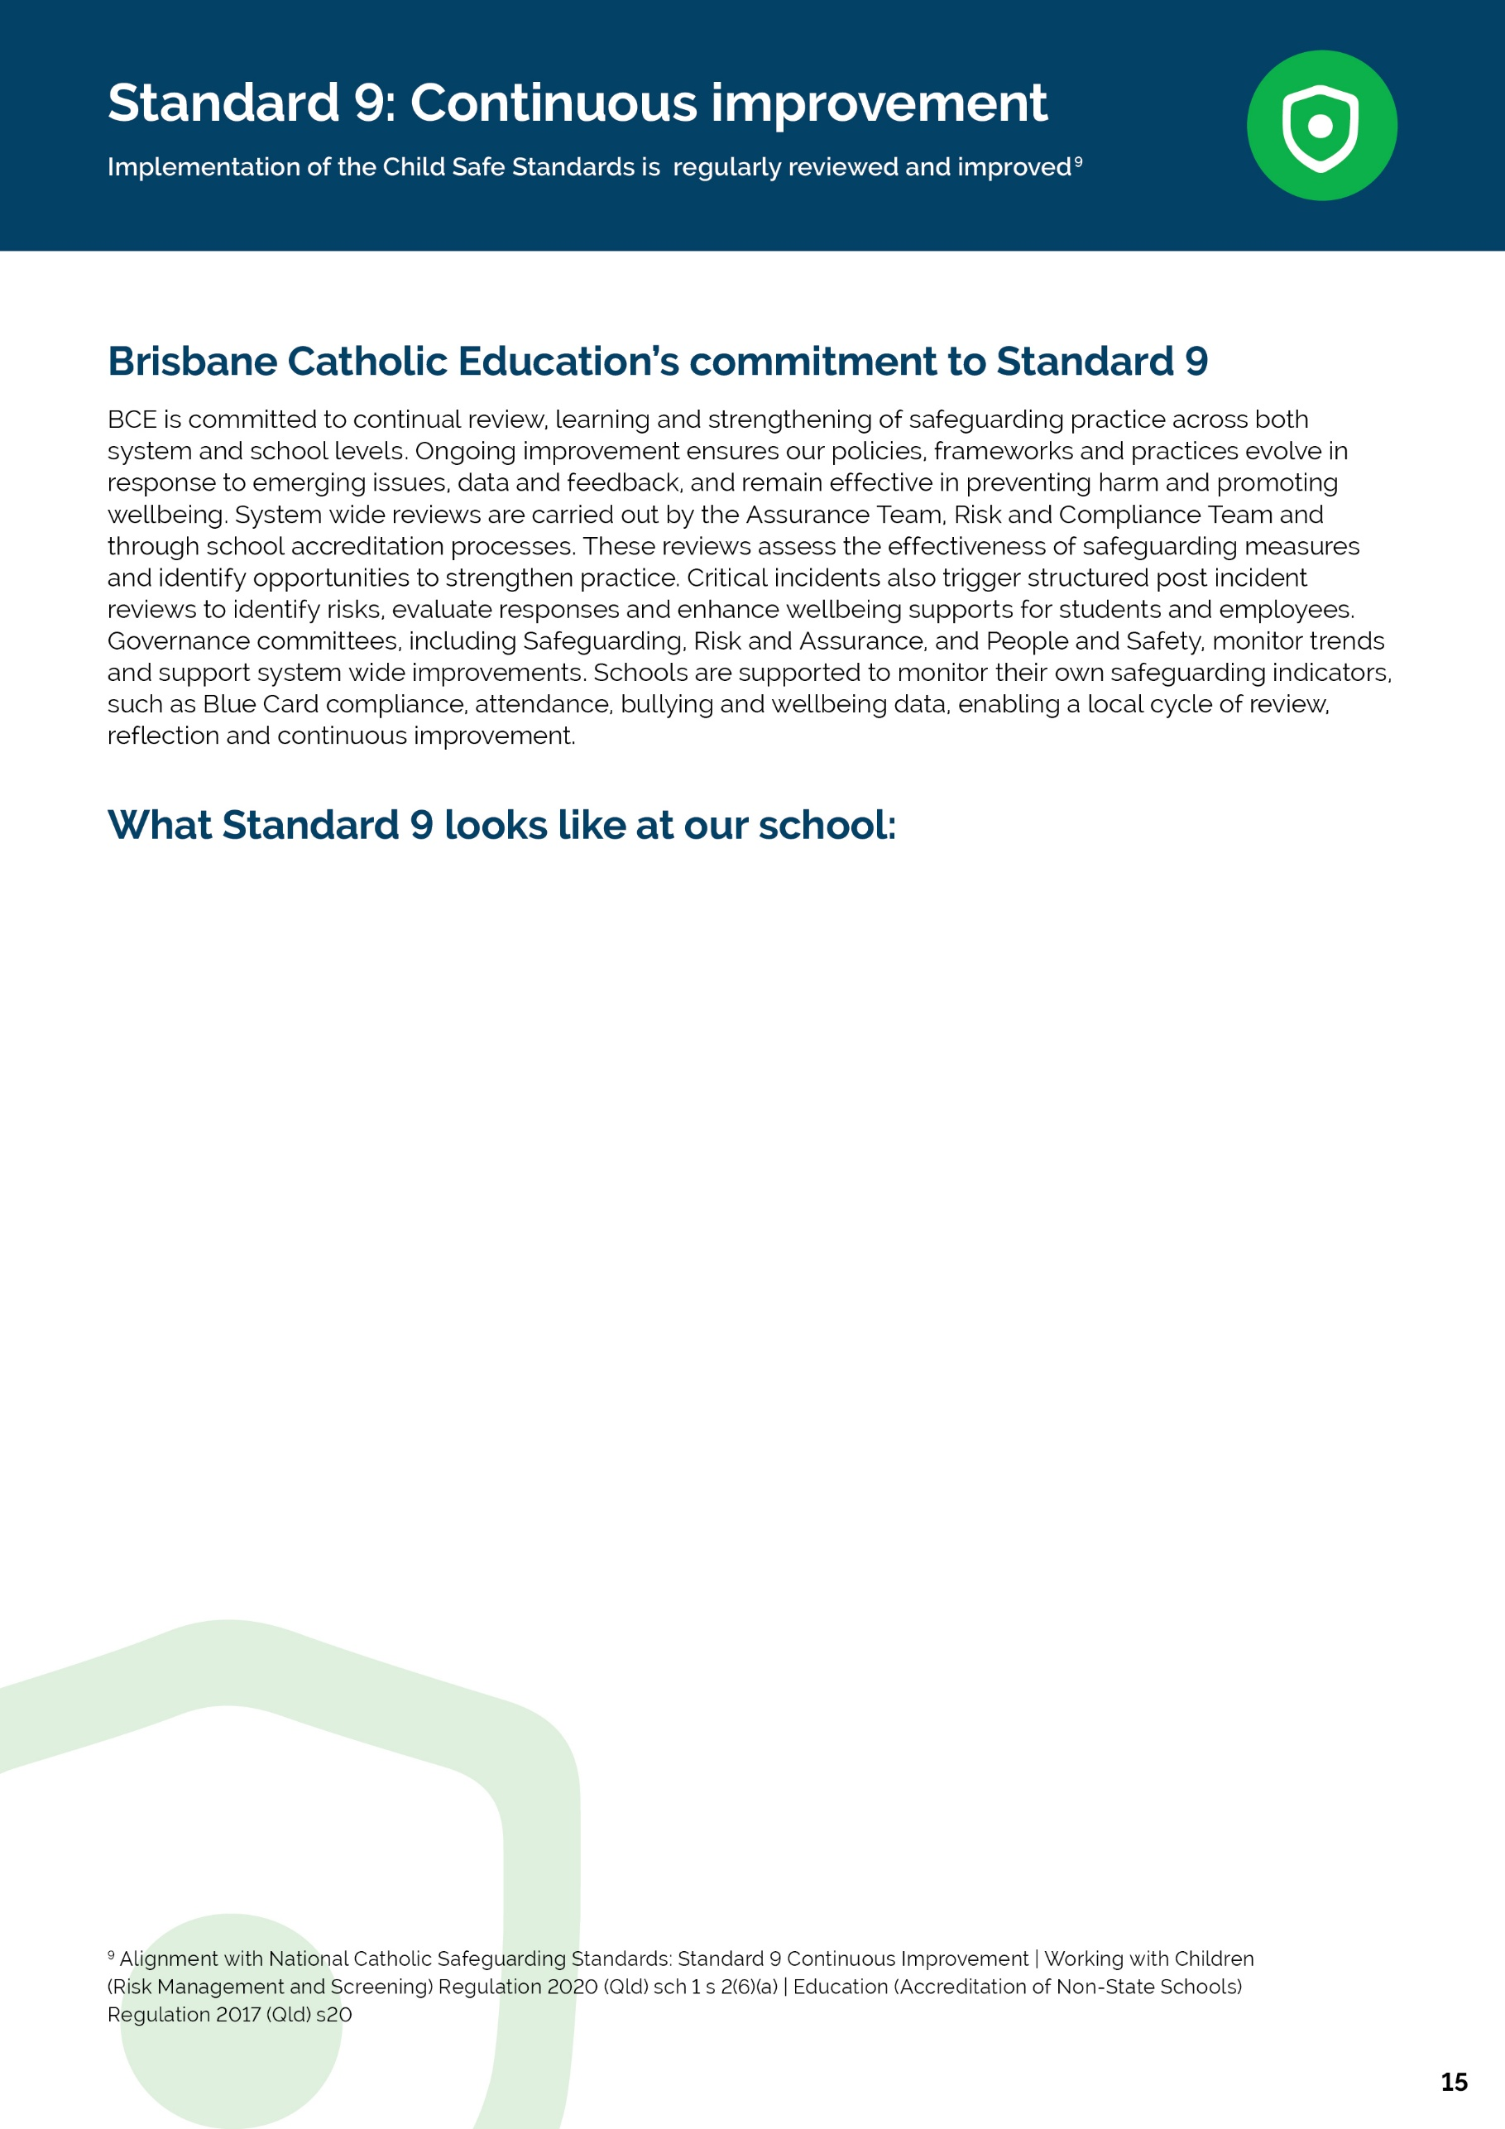
Safeguarding practices at St John’s College are strengthened through clearly articulated expectations outlined in the Staff Handbook 2026. The school’s pastoral framework, grounded in Positive Behaviour for Learning (PB4L) and the Good Samaritan values, provides staff with a shared language around respectful relationships, student dignity and wellbeing. This clarity supports staff confidence in recognising safeguarding responsibilities as part of their everyday role, rather than as an isolated compliance task.
The consistent scheduling of the St John’s College Student Protection Contact (SPC) Team meetings each fortnight and Health and Safety Team Meetings once a term demonstrates that safeguarding concerns are actively monitored and addressed through collaborative professional processes. These meetings provide a clear pathway for staff to raise concerns, share observations, and plan targeted supports, reinforcing staff understanding of when and how to escalate wellbeing or safety issues. The regularity of these meetings supports a culture of shared responsibility for student and staff safety and wellbeing.
The implementation of the Child Safe Standards in 2026 reflects a commitment to culturally safe practice for Aboriginal and Torres Strait Islander students. School documentation and practices acknowledge Traditional Custodians and promote inclusive, relationship-based pastoral care. Student wellbeing planning and support processes consider individual context, including cultural background and family connections, supporting First Nations students to experience safety, respect and belonging within the school community.
In 2026, St John’s College engages in ongoing review and reflection of its safeguarding practices through structured self-assessment and documentation processes. Findings from this process inform supports, evaluation of policy implementation, staff accountability and culturally responsive practice, ensuring that Child Safe Standards are not only implemented but regularly reviewed and strengthened over time.

[St John’s College] | Safeguarding Plan 2026
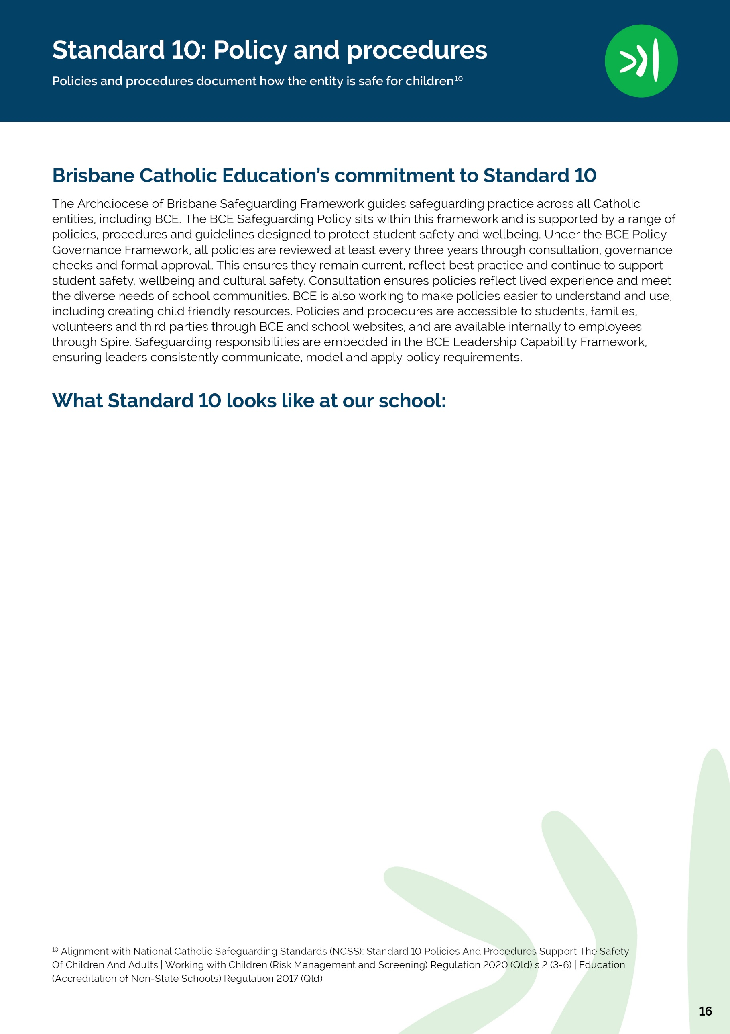
St John’s College, Nambour, maintains a comprehensive suite of school-based policies, procedures, and practices that support child safety and student wellbeing. These are embedded within, and aligned to, Brisbane Catholic Education (BCE) system policies, particularly the BCE Safeguarding Plan 2026, and are enacted through daily practice across the College.
At St John’s College policies and procedures embed all Child Safe Standards and the Universal Principle, are clearly documented, accessible and written in ways that are easy to understand, are informed by best‑practice safeguarding models and system‑level consultation (including First Nations‑led frameworks within BCE), are actively championed and modelled by College leadership, and are well understood and consistently implemented by staff and volunteers through induction, ongoing training and daily practice.
The policies are publicly available from the College website without login requirements however, accessibility is primarily document‑based. While policies are available, users must open and interpret longer PDFs, which may be challenging for some families or students (BCE Policies).
While St John’s College, Nambour demonstrates a strong commitment to reconciliation through culturally inclusive practice, student voice, and engagement with First Nations communities, the College website does not currently present a clearly identified or publicly accessible Reconciliation Action Plan. Greater visibility of a formal RAP, or a consolidated reconciliation overview, would strengthen transparency and community understanding.
Staff and volunteers at St John’s College, Nambour are supported to understand and consistently implement policies and procedures through structured, school‑based induction and ongoing training processes that are fully aligned with Brisbane Catholic Education policies, safeguarding expectations, and system requirements.
[St John’s College] | Safeguarding Plan 2026


