Year 9 2021 TERM 1
Week Beginning | Key Events | Exams/Presentations | Assignments
1 | Swimming Carnival
2
3
4 | Ash Weds | Graphics Sketching exam
5
6
7  8 Mar |  |  | ITD online safety tests due  Mathematics PSMT
8  15Mar | St Patrick’s Day | Humanities Biomes Combination Examination  Legal Studies Combination Examination | Business Investigation Report
9  22Mar |  | Health & Physical Education exam during theory lesson  Media Arts: Digital Folio (Part A)  Drama: Process Drama (Including Journal)  Dance: Performance & Appreciation | RE Assignment  Art: BOW check  Graphics Drawing Folios due
10  29Mar | Easter Liturgy |  | Science Student Investigation (40%)  English Imaginative Gothic assignment  Food studies project folio part A
Year 9 2021 TERM 2
Week | Key Events | Exams/Presentations | Assignments
1 | ANZAC Liturgy.  Cross Country
2
3
4
5
6
7  31May |  |  | Graphics Drawing Folios due  ITD online safety tests due  Food studies folio Due
8  7Jun | Nambour Show Day | Science Coordination and disease Exam Pt1  Mathematics Methods and Essential Exam  Dance: Choreography | Business Portfolio  Health & Physical Education Report due  Digitec Digital Portfolio (webpage and sphero game)  Art: BOW due  Legal Studies Court Report  RE Assignment
9  14Jun |  | Drama: Group Performance  Media Arts: Digital Folio (Part B)  English Analytical Poetry Examination  Mathematics General Exam  Science Chemistry Exam Pt2 (60%) | Humanities Food Security Report  Music: Composition  Food Studies folio  Graphics Production assignment due
10
21Jun
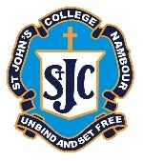
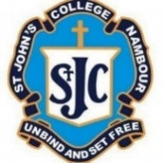
St John’s College Nambour – Year 9 Assessment Schedule - 2021

